Project Title:-Innovative CRM Solutions For Efficient Healthcare Service Management

# Healthcare CRM Application: Comprehensive Healthcare Management Solution

## Project Overview

The Healthcare CRM Application is designed to enhance healthcare service delivery by automating key processes like appointment scheduling, patient management, and decision-making workflows. This application will streamline patient record management, appointment scheduling, provide real-time updates on consultation status, and offer efficient automation to healthcare professionals. Built on Salesforce, it aims to support healthcare organizations in improving patient engagement, optimizing resource allocation, and enhancing overall service delivery.

## 

## Purpose of the CRM Application for Healthcare

The primary purpose of the CRM application is to simplify healthcare workflows, automate administrative tasks, and ensure better collaboration between healthcare providers, patients, and other stakeholders. By centralizing key processes within a unified platform, the application empowers healthcare professionals to:

Manage Patient Information: Easily track patient details, appointment history, and medical records.

Schedule Appointments: Allow patients to schedule consultations with the right healthcare providers, reducing manual work.

Streamline Case Management: Handle patient cases, track progress, and facilitate communication between patients and healthcare professionals.

Monitor Consultant Availability: Ensure consultants are available for appointments, reducing scheduling conflicts.

## Key Features

Appointment Booking: A user-friendly interface allowing patients to book, reschedule, or cancel appointments.

Patient Registration: Simplified registration process for new patients, including health records, contact details, and preferences.

Case Management: Manage patient cases, including diagnosis, treatment, follow-ups, and records.

Automated Email Alerts: Notifications regarding appointment confirmations, cancellations, reminders, and case updates.

Approval Process for Appointments: Automate the review and approval of appointments, ensuring that only confirmed appointments are scheduled.

## Objectives

Improve Operational Efficiency: By automating appointment scheduling and case management, reduce manual tasks and errors.

Enhance Communication: Automated email alerts keep patients and healthcare providers updated on key actions like appointment confirmations and changes.

Streamline Approval Workflow: Automate the approval of appointment requests to ensure the scheduling process is smooth.

Real-time Updates: Provide up-to-date information on consultant availability and appointment statuses.

## Benefits of the Application

Increased Productivity: By automating routine tasks like appointment scheduling and case management, healthcare providers can focus more on patient care.

Improved Patient Satisfaction: Patients can easily book, modify, or cancel appointments, leading to a better experience.

Better Decision-Making: Automated approval processes and real-time data help healthcare administrators make more informed decisions.

Resource Optimization: Ensures the right consultants are available for appointments, preventing overbooking or underutilization.

## Example Workflow

Patient Registration:

A new patient signs up through the CRM, entering personal information and health details.

Appointment Booking:

The patient selects a time slot for an appointment, which automatically checks the consultant's availability.

Approval Process:

The appointment request goes through an automated approval process (if needed) and is updated to “Confirmed.”

Appointment Confirmation:

Once approved, an automated confirmation email is sent to both the patient and the healthcare consultant.

Consultation Completion:

After the appointment, the patient case is updated and relevant actions (e.g., follow-ups) are triggered.

Post-Consultation Communication:

The system sends reminders for follow-up appointments or ongoing treatment.

## Salesforce Key Features and Concepts Utilized

Approval Processes: To manage the routing of appointment requests through different approval steps, ensuring efficient and structured decision-making.

Record-Triggered Flows: Automate actions like updating consultant availability, sending email alerts, and making field updates whenever an appointment is created or modified.

Email Alerts: Predefined templates to notify patients and healthcare providers of appointment status updates, cancellations, or confirmations.

Custom Objects: Create and manage custom objects like Appointment__c and Patient__c to store and track relevant healthcare data.

Profiles & Permissions: Create customized profiles to manage access to different areas of the application, ensuring only authorized users can submit or approve appointments.

Lightning App Pages: Integrate the various workflows and flows into a user-friendly Lightning app for easy access by healthcare professionals.

## Detailed Steps to Solution Design in Salesforce

### Step 1: Define Objects and Fields

Create Custom Objects: Define custom objects for Appointments, Patients, and Cases.

Define Custom Fields: Add necessary fields like Appointment Status, Consultant Availability, Patient Details, etc.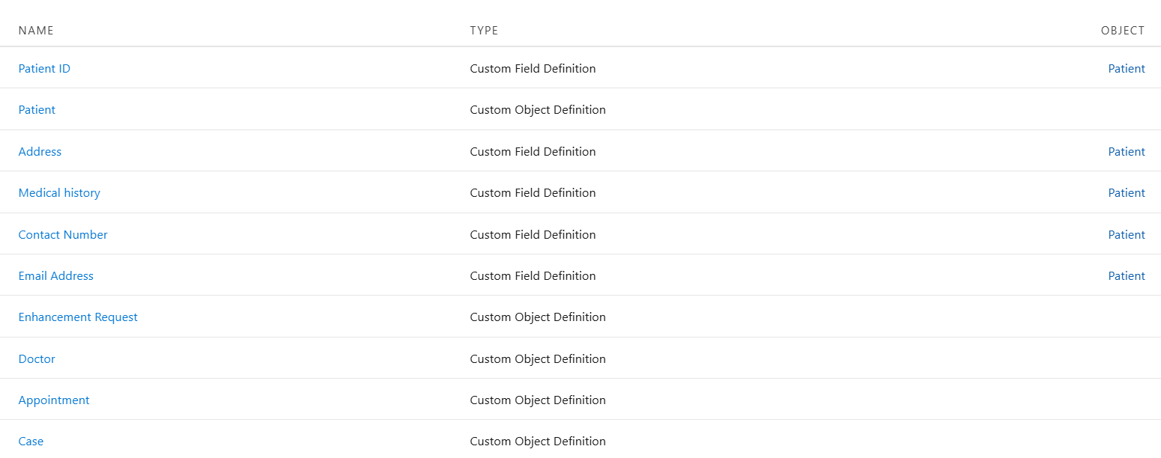

### Step 2: Configure Approval Process

Create Approval Process for Appointment Requests:

Set criteria for when an appointment should be approved (e.g., only when the status is “Scheduled”).

Define actions such as sending email alerts for approval, rejection, and status updates.

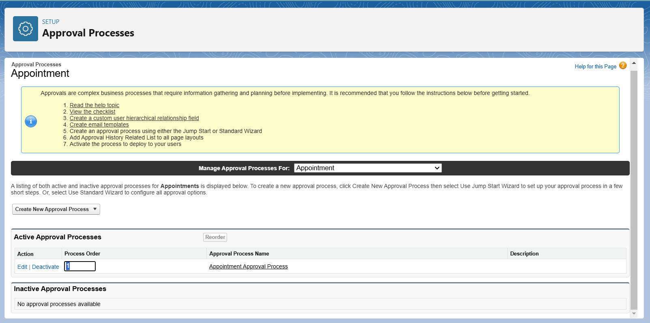

### Step 3: Automate Appointment Management with Flows

Create Record-Triggered Flows:

Trigger flows when an Appointment__c record is created or updated.

Actions to automate include marking the consultant as unavailable during an appointment and sending confirmation emails to patients and healthcare providers.

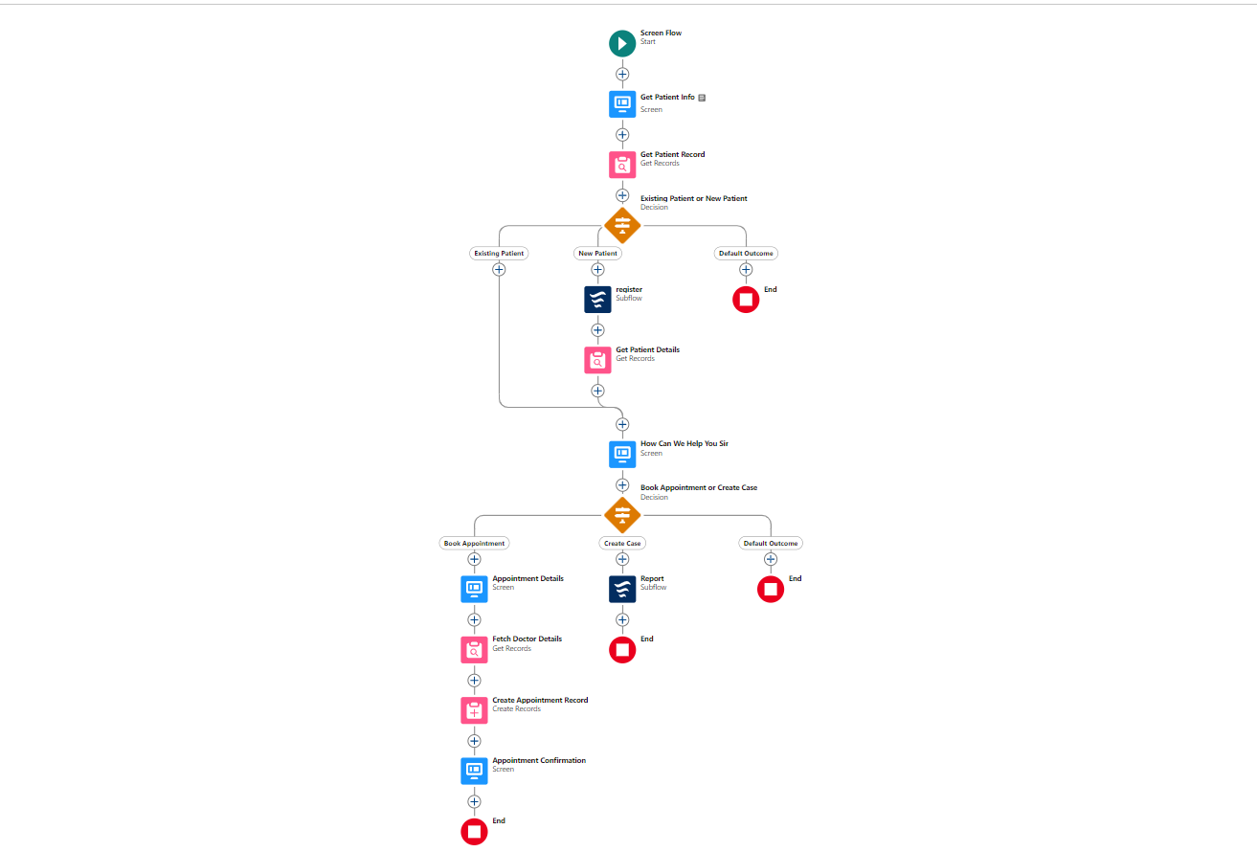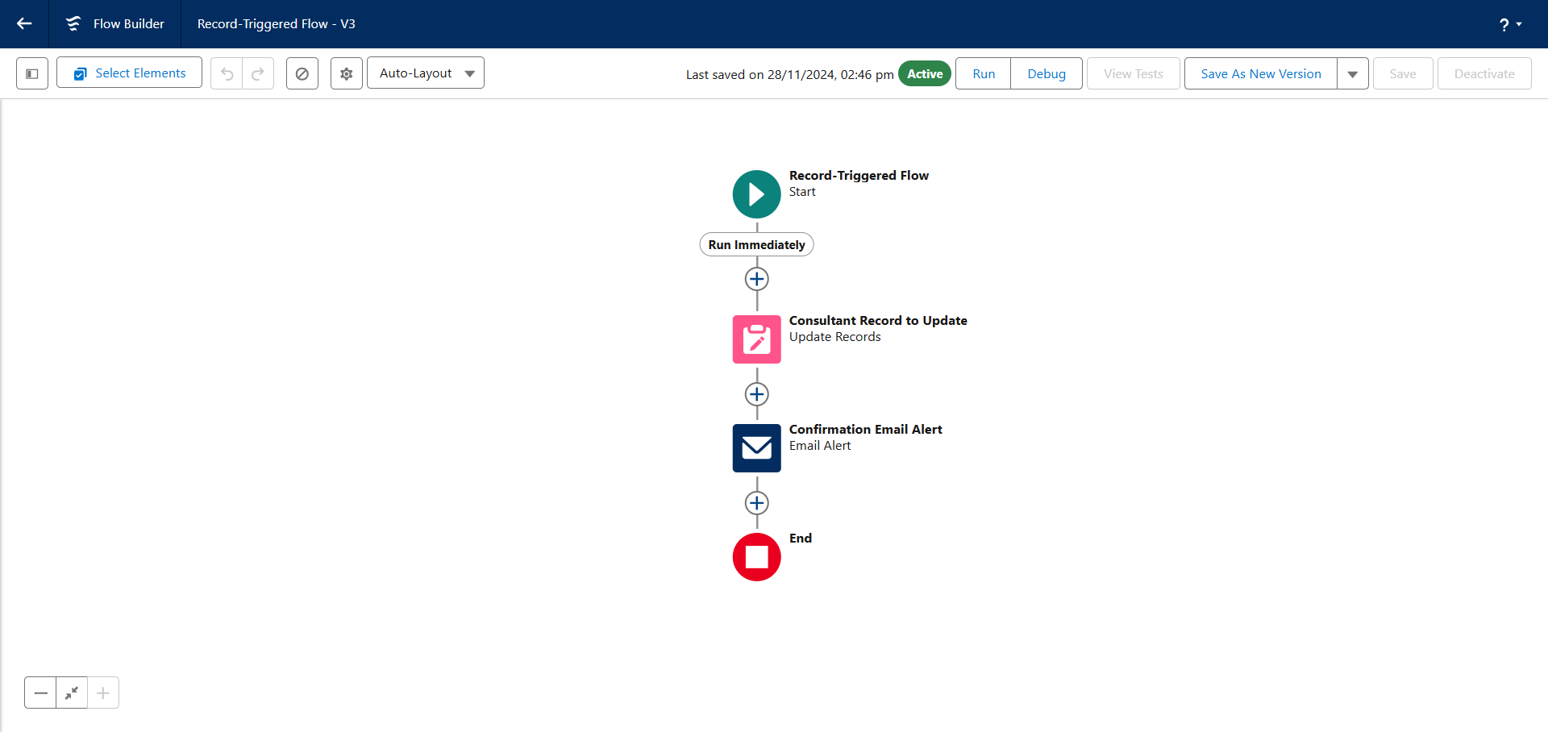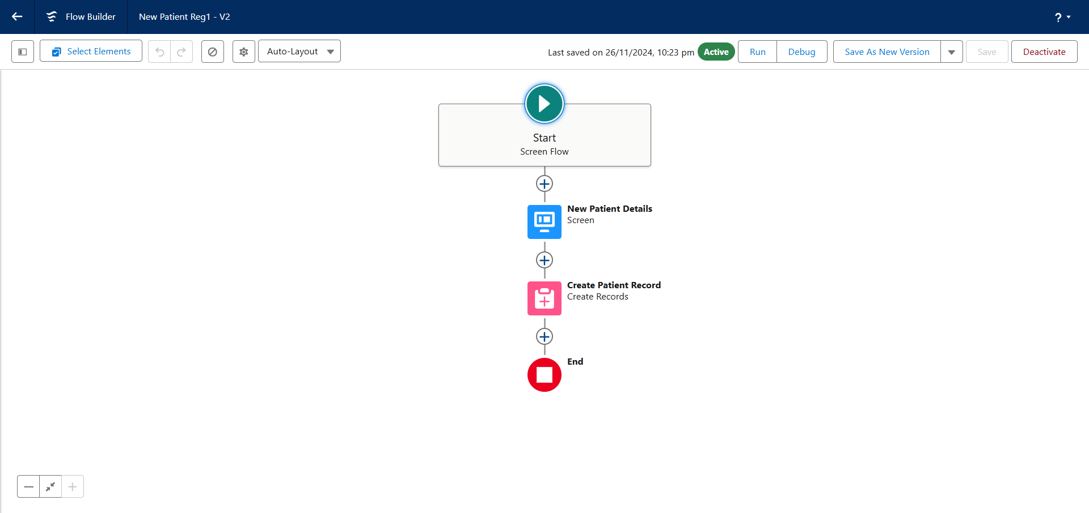

### Step 4: Set Up Email Alerts and Templates

Create Email Templates:

Set up email templates for appointment confirmation, rescheduling, and cancellations.

Use dynamic fields to include patient names, appointment times, and consultant names.

Add Email Alerts to the Flow:

Configure the flow to automatically send email alerts based on appointment status updates or changes.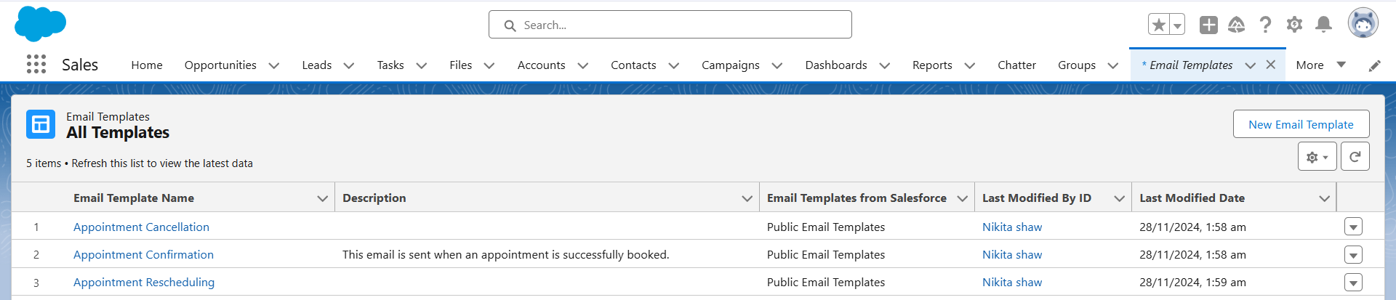

### Step 5: Configure Lightning App Pages

Create a Home Page:

Create a user-friendly Lightning Home Page to host key flows, such as Appointment Booking, Patient Registration, and Case Management.

Add components for each flow, so users can quickly access the necessary features.

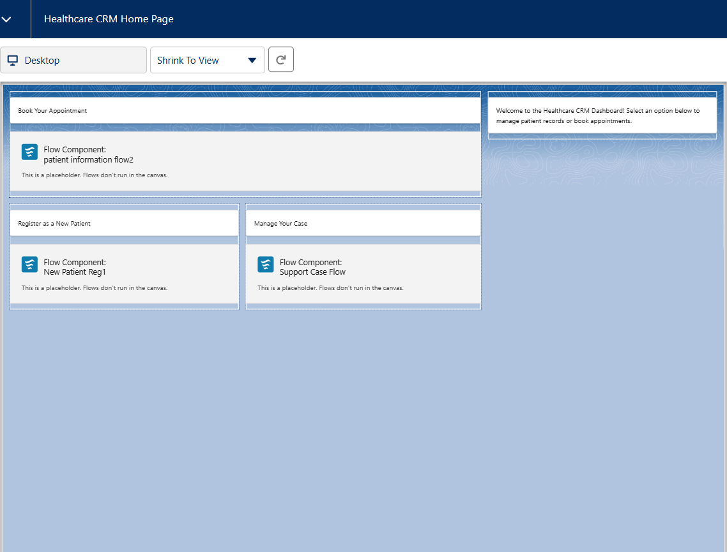

### Step 6: Testing and Activation

Test the Solution:

Test the entire workflow by simulating appointment bookings, approvals, email alerts, and status updates.

Activate the Flows and App Page:

Once everything is configured and tested, activate the flows and the Lightning app for healthcare professionals.

### Step 7: Create Users and Assign Profiles

Create Users:

Create users for healthcare providers, admins, and other stakeholders. Assign them appropriate roles and profiles (e.g., Healthcare Consultant or Administrator).

Assign Profiles to Flows:

Ensure the correct permissions are set so that each user can access the necessary features and flows.

This documentation structure gives a clear overview of your project’s purpose, features, objectives, and detailed steps for solution design. It can serve as a foundation for any future enhancements or modifications to the CRM.